**A**

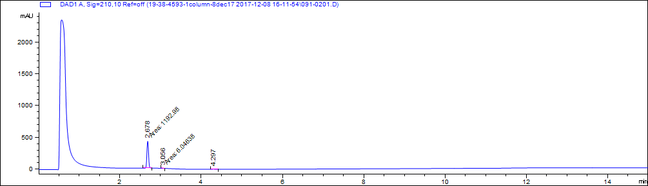

|  |  |  |  |
| --- | --- | --- | --- |
| # | Retention time (minutes) | area | Area% |
| 1 | 2.7 | 1193 | 98.5 |
| 2 | 3.1 | 6 | 0.5 |
| 3 | 4.3 | 11.9 | 1.0 |

**B**



M+1

2M+Na

**SI Figure 1.** LC-MS chromatograms for M01. Molecular weight estimated from mass spectrometry is 217.221 g/mol. (A) LC chromatogram and table of peak properties. %Area describes relative area under the curve of selected peaks and interpreted as an estimate of purity. (B) MS detection.

**A**

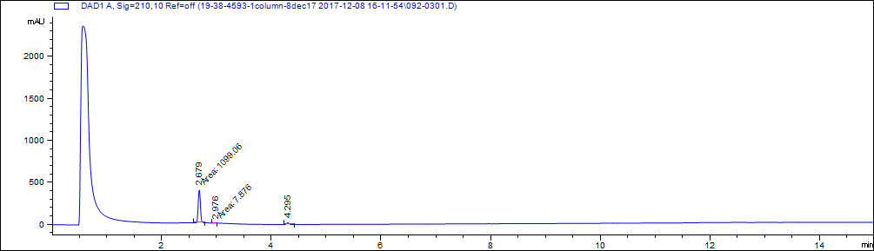

|  |  |  |  |
| --- | --- | --- | --- |
| # | Retention time (minutes) | Area | Area% |
| 1 | 2.7 | 1099.1 | 94.2 |
| 2 | 3.0 | 7.9 | 0.68 |
| 3 | 4.3 | 59.5 | 5.1 |

**B**



M+1

**SI Figure 2.** LC-MS chromatograms for M01-2. Molecular weight estimated from mass spectrometry is 217.221 g/mol. (A) LC chromatogram and table of peak properties. %Area describes relative area under the curve of selected peaks and interpreted as an estimate of purity. (B) MS detection.

**A**

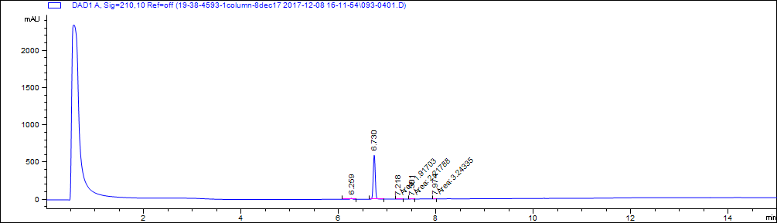

|  |  |  |  |
| --- | --- | --- | --- |
| # | Retention time (minutes) | Area | Area% |
| 1 | 6.3 | 34.9 | 2.0 |
| 2 | 6.7 | 1733.8 | 97.6 |
| 3 | 7.2 | 1.9 | 0.1 |
| 4 | 7.5 | 2.2 | 0.1 |
| 5 | 8.0 | 3.2 | 0.2 |

**B**

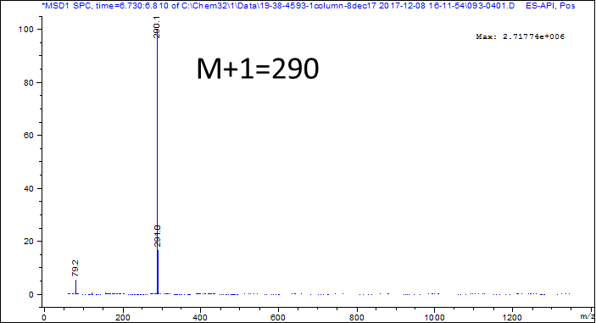

**SI Figure 3.** LC-MS chromatograms for M02. Molecular weight estimated from mass spectrometry is 289.255 g/mol. (A) LC chromatogram and table of peak properties. %Area describes relative area under the curve of selected peaks and interpreted as an estimate of purity. (B) MS detection.

**A**

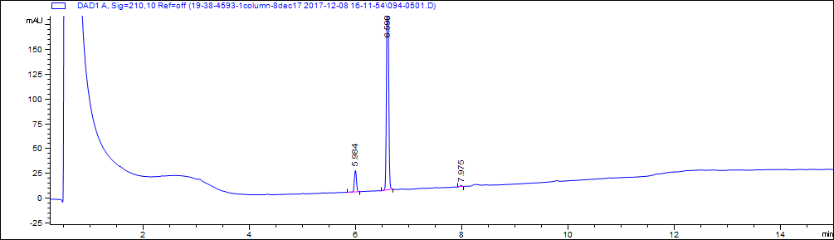

|  |  |  |  |
| --- | --- | --- | --- |
| # | Retention time (minutes) | Area | Area% |
| 1 | 6.0 | 58.2 | 8.7 |
| 2 | 6.6 | 606.7 | 90.8 |
| 3 | 8.0 | 3.3 | 0.5 |

**B**

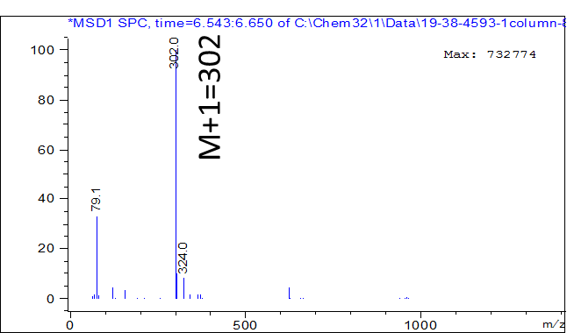

**SI Figure 4.** LC-MS chromatograms for M03. Molecular weight estimated from mass spectrometry is 301.387 g/mol. (A) LC chromatogram and table of peak properties. %Area describes relative area under the curve of selected peaks and interpreted as an estimate of purity. (B) MS detection.

**A**

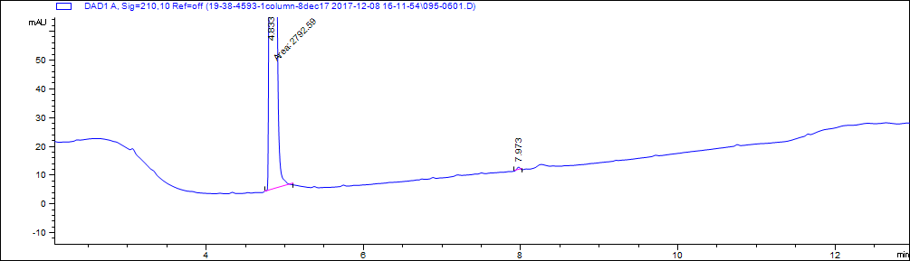

|  |  |  |  |
| --- | --- | --- | --- |
| # | Retention time (minutes) | Area | Area% |
| 1 | 4.8 | 2792.6 | 99.9 |
| 2 | 8.0 | 3.2 | 0.1 |

**B**

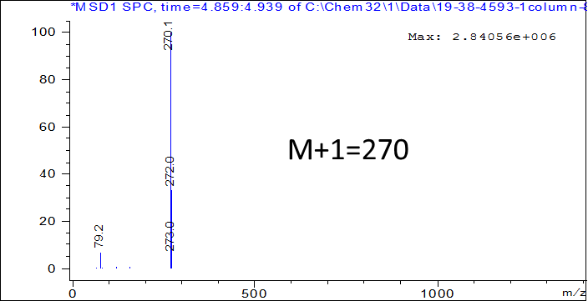

**SI Figure 5.** LC-MS chromatograms for M04. Molecular weight estimated from mass spectrometry is 269.729 g/mol. (A) LC chromatogram and table of peak properties. %Area describes relative area under the curve of selected peaks and interpreted as an estimate of purity. (B) MS detection.

**A**

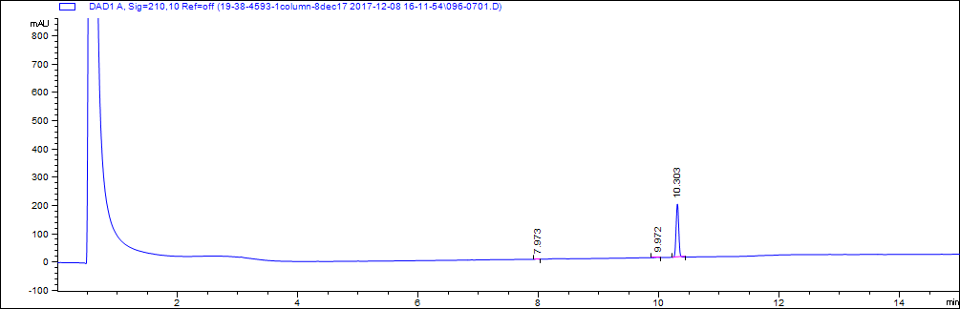

|  |  |  |  |
| --- | --- | --- | --- |
| # | Retention time (minutes) | Area | Area% |
| 1 | 8.0 | 3.3 | 0.6 |
| 2 | 10.0 | 4 | 0.7 |
| 3 | 10.3 | 569.7 | 98.7 |

**B**

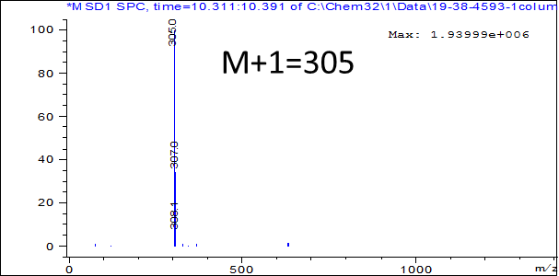

**SI Figure 6.** LC-MS chromatograms for M05. Molecular weight estimated from mass spectrometry is 304.771 g/mol. (A) LC chromatogram and table of peak properties. %Area describes relative area under the curve of selected peaks and interpreted as an estimate of purity. (B) MS detection.

**A**

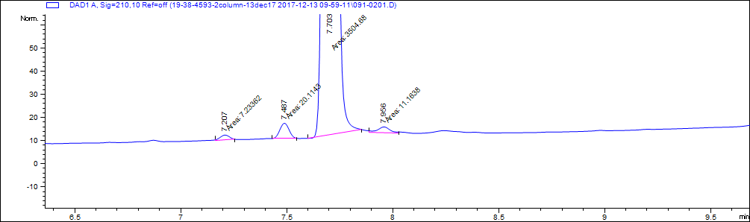

|  |  |  |  |
| --- | --- | --- | --- |
| # | Retention time (minutes) | Area | Area% |
| 1 | 7.2 | 7.2 | 0.2 |
| 2 | 7.5 | 20.1 | 0.6 |
| 3 | 7.7 | 3504.7 | 98.9 |
| 4 | 8.0 | 11.2 | 0.3 |

**B**

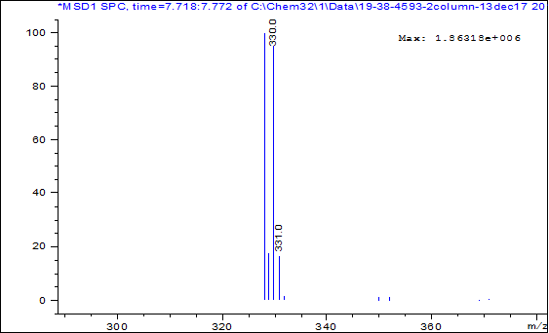

M/Z=328 and 330

**SI Figure 7.** LC-MS chromatograms for M06. Molecular weight estimated from mass spectrometry is 328.163 g/mol. (A) LC chromatogram and table of peak properties. %Area describes relative area under the curve of selected peaks and interpreted as an estimate of purity. (B) MS detection.

**A**

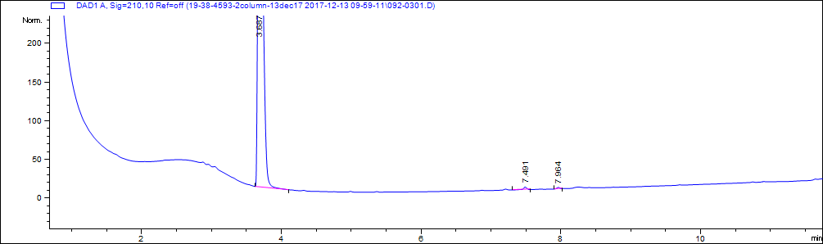

|  |  |  |  |
| --- | --- | --- | --- |
| # | Retention time (minutes) | Area | Area% |
| 1 | 3.7 | 2822.4 | 99.4 |
| 2 | 7.5 | 11.3 | 0.4 |
| 3 | 8.0 | 6.2 | 0.2 |

**B**



M+1=236

**SI Figure 8.** LC-MS chromatograms for M07. Molecular weight estimated from mass spectrometry is 235.284 g/mol. (A) LC chromatogram and table of peak properties. %Area describes relative area under the curve of selected peaks and interpreted as an estimate of purity. (B) MS detection.

**A**

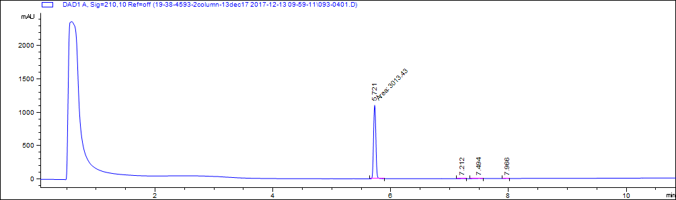

|  |  |  |  |
| --- | --- | --- | --- |
| # | Retention time (minutes) | Area | Area% |
| 1 | 5.7 | 3013.4 | 99.2 |
| 2 | 7.2 | 5 | 0.2 |
| 3 | 7.5 | 11.1 | 0.4 |
| 4 | 8.0 | 6.9 | 0.2 |

**B**

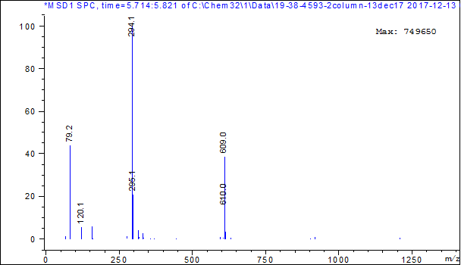

M+1=294

**SI Figure 9.** LC-MS chromatograms for M08. Molecular weight estimated from mass spectrometry is 293.317 g/mol. (A) LC chromatogram and table of peak properties. %Area describes relative area under the curve of selected peaks and interpreted as an estimate of purity. (B) MS detection.

**A**

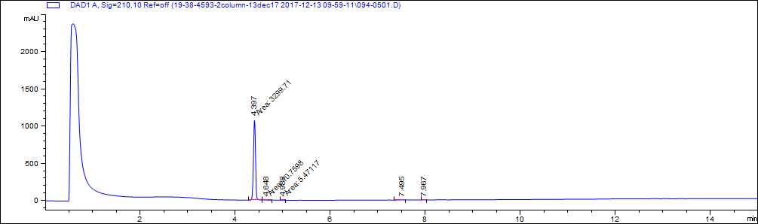

|  |  |  |  |
| --- | --- | --- | --- |
| # | Retention time (minutes) | Area | Area% |
| 1 | 4.4 | 3299.7 | 99.0 |
| 2 | 4.6 | 10.8 | 0.3 |
| 3 | 5.0 | 5.5 | 0.2 |
| 4 | 7.5 | 12.6 | 0.4 |
| 5 | 8.0 | 5.7 | 0.2 |

**B**

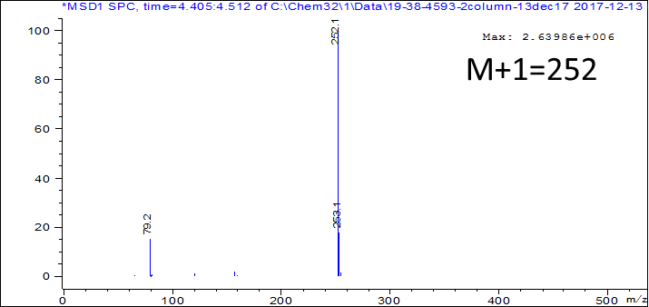

**SI Figure 10.** LC-MS chromatograms for M09. Molecular weight estimated from mass spectrometry is 287.744 g/mol (m/z = 251.244). (A) LC chromatogram and table of peak properties. %Area describes relative area under the curve of selected peaks and interpreted as an estimate of purity. (B) MS detection.

**A**

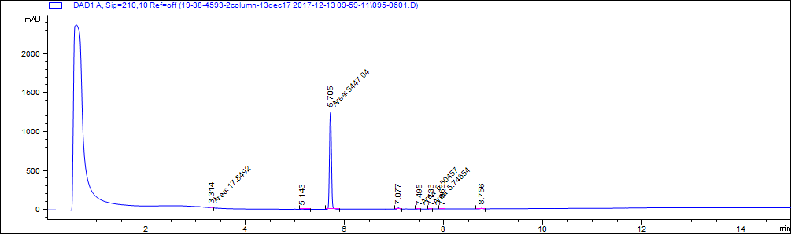

|  |  |  |  |
| --- | --- | --- | --- |
| # | Retention time (minutes) | Area | Area% |
| 2 | 5.1 | 5.2 | 0.1 |
| 3 | 5.7 | 3447 | 97.0 |
| 4 | 7.1 | 43.7 | 1.2 |
| 5 | 7.5 | 6.5 | 0.2 |
| 6 | 7.7 | 5.7 | 0.2 |
| 7 | 8.0 | 6.8 | 0.2 |
| 8 | 8.8 | 21.5 | 0.6 |

**B**



M+1=312

**SI Figure 11.** LC-MS chromatograms for M10. Molecular weight estimated from mass spectrometry is 311.358 g/mol. (A) LC chromatogram and table of peak properties. %Area describes relative area under the curve of selected peaks and interpreted as an estimate of purity. (B) MS detection.

**A**

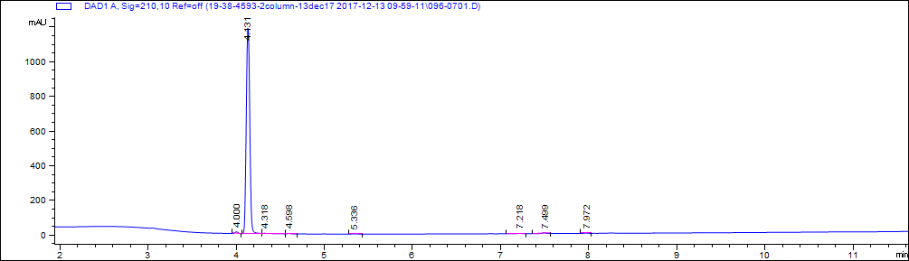

|  |  |  |  |
| --- | --- | --- | --- |
| # | Retention time (minutes) | Area | Area% |
| 1 | 4 | 25.1 | 0.8 |
| 2 | 4.1 | 3281.8 | 98.0 |
| 3 | 4.6 | 5.6 | 0.2 |
| 4 | 5.3 | 6.5 | 0.2 |
| 5 | 7.2 | 7.1 | 0.2 |
| 6 | 7.5 | 15.2 | 0.5 |
| 7 | 8.0 | 6.8 | 0.2 |

**B**



M+1=212

**SI Figure 12.** LC-MS chromatograms for M11. Molecular weight estimated from mass spectrometry is 211.233 g/mol. (A) LC chromatogram and table of peak properties. %Area describes relative area under the curve of selected peaks and interpreted as an estimate of purity. (B) MS detection.

**A**

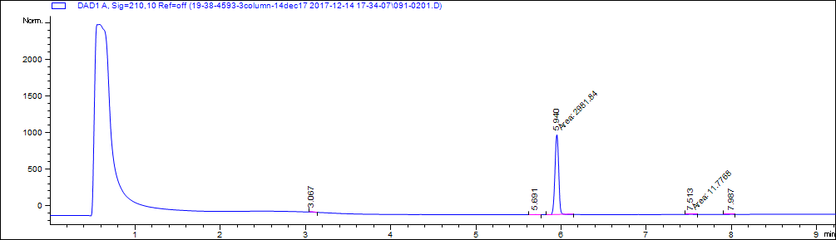

|  |  |  |  |
| --- | --- | --- | --- |
| # | Retention time (minutes) | Area | Area% |
| 1 | 3.1 | 5.1 | 0.2 |
| 2 | 5.7 | 7.3 | 0.2 |
| 3 | 5.9 | 2981.8 | 98.1 |
| 4 | 7.5 | 11.8 | 0.4 |
| 5 | 8.0 | 6.7 | 0.2 |
| 6 | 12.3 | 25.7 | 0.8 |

**B**



M-1=254

M+1=256

**SI Figure 13.** LC-MS chromatograms for M12. Molecular weight estimated from mass spectrometry is 292.163 g/mol (m/z = 255). (A) LC chromatogram and table of peak properties. %Area describes relative area under the curve of selected peaks and interpreted as an estimate of purity. (B) MS detection.

**A**

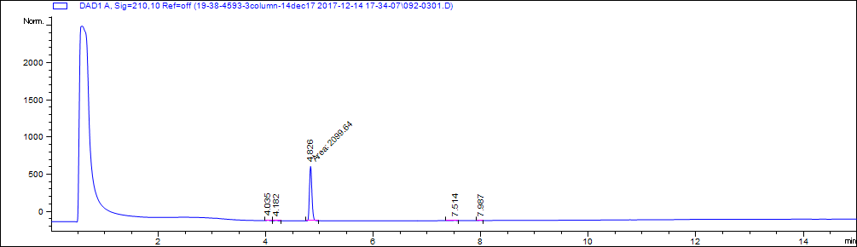

|  |  |  |  |
| --- | --- | --- | --- |
| # | Retention time (minutes) | Area | Area% |
| 1 | 4.0 | 18.1 | 0.8 |
| 2 | 4.2 | 15.4 | 0.7 |
| 3 | 4.8 | 2099.6 | 97.5 |
| 4 | 7.5 | 13.5 | 0.6 |
| 5 | 8.0 | 6.5 | 0.3 |

**B**



M+1=296

**SI Figure 14.** LC-MS chromatograms for M13. Molecular weight estimated from mass spectrometry is 295.336 g/mol. (A) LC chromatogram and table of peak properties. %Area describes relative area under the curve of selected peaks and interpreted as an estimate of purity. (B) MS detection.

**A**

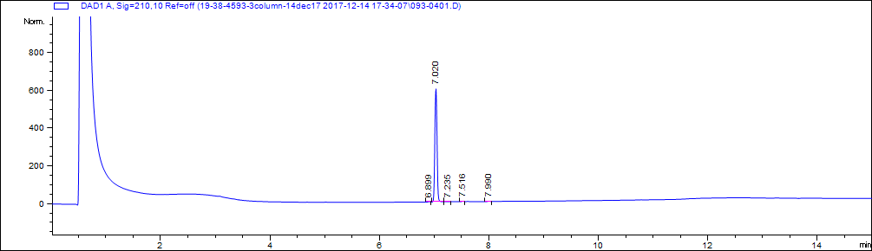

|  |  |  |  |
| --- | --- | --- | --- |
| # | Retention time (minutes) | Area | Area% |
| 1 | 6.9 | 5.4 | 0.3 |
| 2 | 7.0 | 1667.3 | 98.4 |
| 3 | 7.2 | 7.0 | 0.4 |
| 4 | 7.5 | 7.4 | 0.4 |
| 5 | 8.0 | 6.6 | 0.4 |

**B**



M+1=320

**SI Figure 15.** LC-MS chromatograms for M14. Molecular weight estimated from mass spectrometry is 319.2984 g/mol. (A) LC chromatogram and table of peak properties. %Area describes relative area under the curve of selected peaks and interpreted as an estimate of purity. (B) MS detection.

**A**

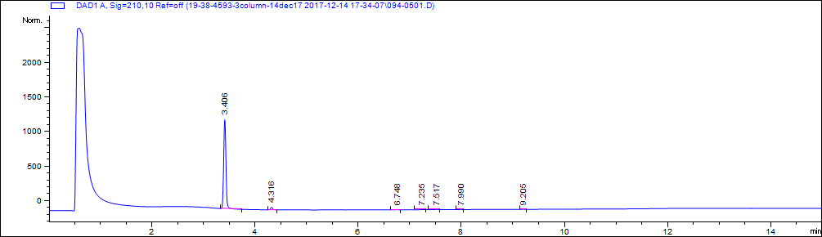

|  |  |  |  |
| --- | --- | --- | --- |
| # | Retention time (minutes) | Area | Area% |
| 1 | 3.4 | 3561.5 | 96.5 |
| 2 | 4.3 | 90.1 | 2.4 |
| 3 | 6.7 | 7.5 | 0.2 |
| 4 | 7.2 | 5.9 | 0.2 |
| 5 | 7.5 | 14.3 | 0.4 |
| 6 | 8.0 | 6.6 | 0.2 |
| 7 | 9.2 | 5.3 | 0.1 |

**B**



M+1=210

**SI Figure 16.** LC-MS chromatograms for M15. Molecular weight estimated from mass spectrometry is 209.247 g/mol. (A) LC chromatogram and table of peak properties. %Area describes relative area under the curve of selected peaks and interpreted as an estimate of purity. (B) MS detection.

**A**



|  |  |  |  |
| --- | --- | --- | --- |
| # | Retention time (minutes) | Area | Area% |
| 1 | 4.4 | 2822.7 | 98.7 |
| 2 | 5.5 | 15.6 | 0.5 |
| 3 | 5.8 | 5.5 | 0.9 |
| 4 | 7.5 | 9.4 | 1.2 |
| 5 | 8.0 | 6.7 | 1.0 |

**B**



**SI Figure 17.** LC-MS chromatograms for M16. Molecular weight estimated from mass spectrometry is 210.231 g/mol. (A) LC chromatogram and table of peak properties. %Area describes relative area under the curve of selected peaks and interpreted as an estimate of purity. (B) MS detection.

**A**

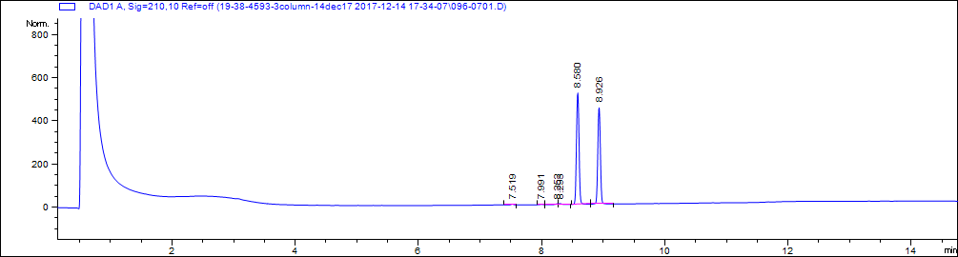

|  |  |  |  |
| --- | --- | --- | --- |
| # | Retention time (minutes) | Area | Area% |
| 1 | 7.5 | 11.2 | 0.4 |
| 2 | 8.0 | 6.3 | 0.2 |
| 3 | 8.25 | 12.7 | 0.2 |
| 4 | 8.29 | 16.1 | 0.6 |
| 5 | 8.6 | 1504.5 | 52.6 |
| 6 | 8.9 | 1309.9 | 45.8 |

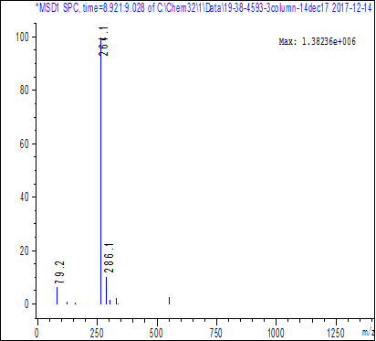**B**

M+1=264



M+1=264

**SI Figure 18.** LC-MS chromatograms for M17. Molecular weight estimated from mass spectrometry is 263.33 g/mol. (A) LC chromatogram and table of peak properties. %Area describes relative area under the curve of selected peaks and interpreted as an estimate of purity. (B) MS detection.

**A**

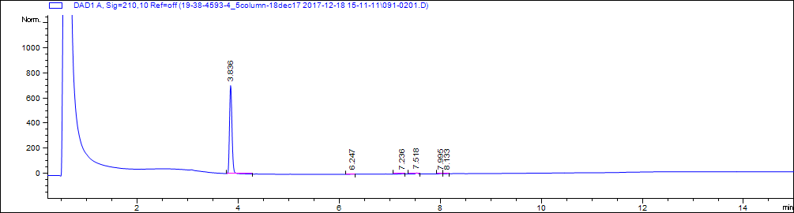

|  |  |  |  |
| --- | --- | --- | --- |
| # | Retention time (minutes) | Area | Area% |
| 1 | 3.8 | 2375.8 | 97.7 |
| 2 | 6.2 | 5.3 | 0.2 |
| 3 | 7.2 | 9.6 | 0.4 |
| 4 | 7.5 | 23.9 | 1.0 |
| 5 | 8.0 | 10.2 | 0.4 |
| 6 | 8.1 | 6.1 | 0.3 |

**B**



M/Z=267,269

**SI Figure 19.** LC-MS chromatograms for M18. Molecular weight estimated from mass spectrometry is 267.111 g/mol. (A) LC chromatogram and table of peak properties. %Area describes relative area under the curve of selected peaks and interpreted as an estimate of purity. (B) MS detection.

**A**

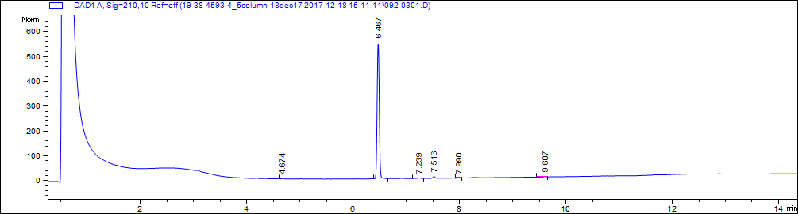

|  |  |  |  |
| --- | --- | --- | --- |
| # | Retention time (minutes) | Area | Area% |
| 1 | 4.7 | 5.3 | 0.3 |
| 2 | 6.5 | 1541.6 | 97.0 |
| 3 | 7.2 | 7.3 | 0.5 |
| 4 | 7.5 | 22.5 | 1.4 |
| 5 | 8.0 | 6.4 | 0.4 |
| 6 | 9.6 | 6.3 | 0.4 |

**B**



M+1=270

**SI Figure 20.** LC-MS chromatograms for M19. Molecular weight estimated from mass spectrometry is 269.322 g/mol. (A) LC chromatogram and table of peak properties. %Area describes relative area under the curve of selected peaks and interpreted as an estimate of purity. (B) MS detection.

**A**

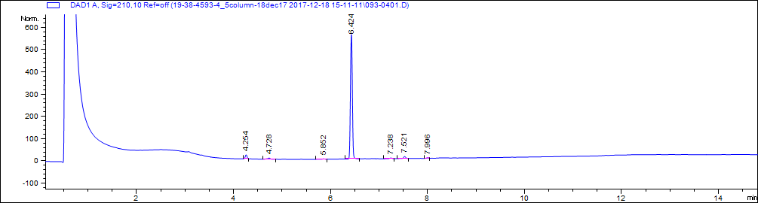

|  |  |  |  |
| --- | --- | --- | --- |
| # | Retention time (minutes) | Area | Area% |
| 1 | 4.3 | 47.8 | 2.9 |
| 2 | 4.7 | 22.5 | 1.4 |
| 3 | 5.9 | 5.7 | 0.3 |
| 4 | 6.4 | 1538.3 | 92.6 |
| 5 | 7.2 | 10.7 | 0.6 |
| 6 | 7.5 | 28.5 | 1.7 |
| 7 | 8.0 | 7.8 | 0.5 |

**B**



M+1=427

**SI Figure 21.** LC-MS chromatograms for D01. Molecular weight estimated from mass spectrometry is 426.439 g/mol. (A) LC chromatogram and table of peak properties. %Area describes relative area under the curve of selected peaks and interpreted as an estimate of purity. (B) MS detection.

**A**

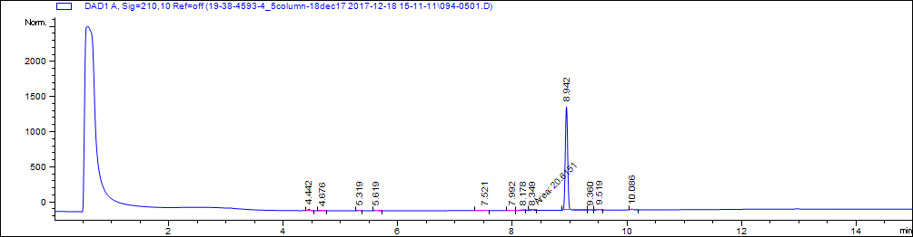

|  |  |  |  |
| --- | --- | --- | --- |
| # | Retention time (minutes) | Area | Area% |
| 1 | 4.4 | 51.6 | 1.3 |
| 2 | 4.7 | 5.7 | 0.1 |
| 3 | 5.3 | 14.3 | 0.3 |
| 4 | 5.6 | 17.8 | 0.4 |
| 5 | 7.5 | 17.4 | 0.4 |
| 6 | 8.0 | 8.2 | 0.2 |
| 7 | 8.2 | 14.1 | 0.3 |
| 8 | 8.3 | 20.6 | 0.5 |
| 9 | 8.9 | 3893.8 | 94.5 |
| 10 | 9.4 | 15.4 | 0.4 |
| 11 | 9.5 | 26.1 | 0.6 |
| 12 | 10.1 | 37.1 | 0.9 |

**B**



M/Z=381 and 383

**SI Figure 22.** LC-MS chromatograms for D02. Molecular weight estimated from mass spectrometry is 381.276 g/mol. (A) LC chromatogram and table of peak properties. %Area describes relative area under the curve of selected peaks and interpreted as an estimate of purity. (B) MS detection.

**A**

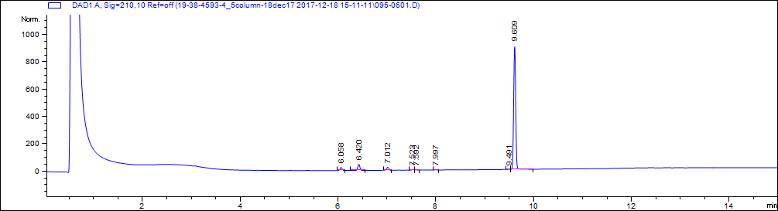

|  |  |  |  |
| --- | --- | --- | --- |
| # | Retention time (minutes) | Area | Area% |
| 1 | 6.1 | 66.4 | 2.3 |
| 2 | 6.4 | 136 | 4.6 |
| 3 | 7.0 | 70.6 | 2.4 |
| 4 | 7.5 | 16.3 | 0.6 |
| 5 | 7.6 | 5.6 | 0.2 |
| 6 | 8.0 | 5.5 | 0.2 |
| 7 | 9.5 | 5.0 | 0.2 |
| 8 | 9.6 | 2647.6 | 89.7 |

**B**



M/Z=403 and 405

**SI Figure 23.** LC-MS chromatograms for D03. Molecular weight estimated from mass spectrometry is 403.305 g/mol. (A) LC chromatogram and table of peak properties. %Area describes relative area under the curve of selected peaks and interpreted as an estimate of purity. (B) MS detection.

**A**

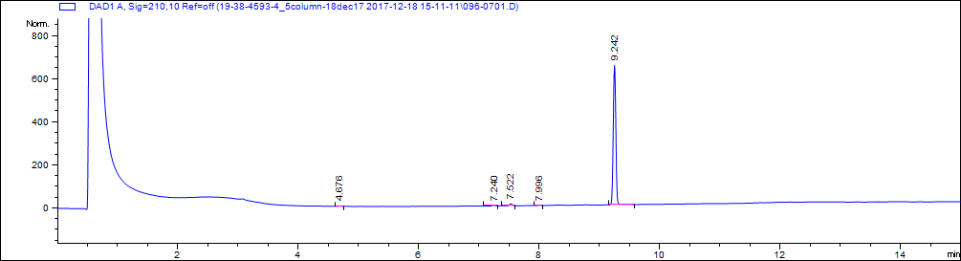

|  |  |  |  |
| --- | --- | --- | --- |
| # | Retention time (minutes) | Area | Area% |
| 1 | 4.7 | 5.7 | 0.3 |
| 2 | 7.2 | 10.8 | 0.5 |
| 3 | 7.5 | 30.4 | 1.5 |
| 4 | 8.0 | 6.7 | 0.3 |
| 5 | 9.2 | 1919.1 | 97.3 |

**B**



M+1=402

**SI Figure 24.** LC-MS chromatograms for D04. Molecular weight estimated from mass spectrometry is 401.481 g/mol. (A) LC chromatogram and table of peak properties. %Area describes relative area under the curve of selected peaks and interpreted as an estimate of purity. (B) MS detection.

**A**

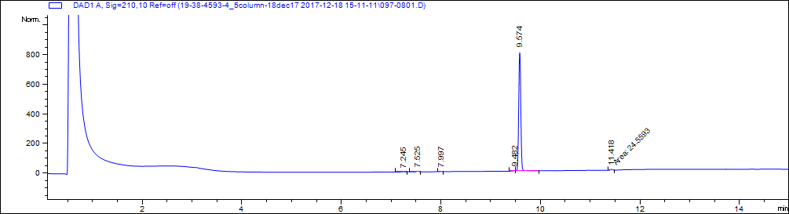

|  |  |  |  |
| --- | --- | --- | --- |
| # | Retention time (minutes) | Area | Area% |
| 1 | 7.2 | 5.6 | 0.2 |
| 2 | 7.5 | 16.4 | 0.7 |
| 3 | 8.0 | 7.0 | 0.3 |
| 4 | 9.5 | 15.4 | 0.6 |
| 5 | 9.6 | 2376.4 | 97.2 |
| 6 | 11.4 | 24.6 | 1.0 |

**B**

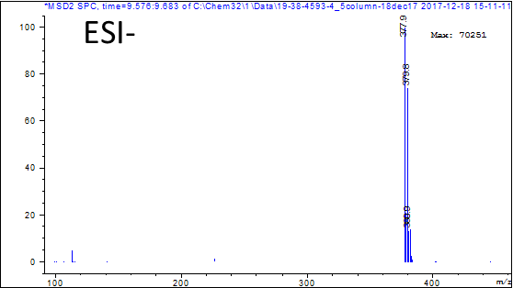

M/Z=378 and380

**SI Figure 25.** LC-MS chromatograms for D05. Molecular weight estimated from mass spectrometry is 380.245 g/mol. (A) LC chromatogram and table of peak properties. %Area describes relative area under the curve of selected peaks and interpreted as an estimate of purity. (B) MS detection.

**A**

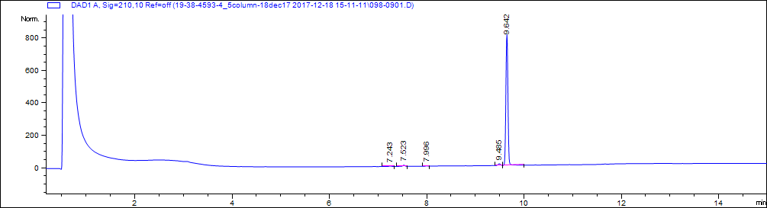

|  |  |  |  |
| --- | --- | --- | --- |
| # | Retention time (minutes) | Area | Area% |
| 1 | 7.2 | 9.1 | 0.4 |
| 2 | 7.5 | 23.6 | 1.0 |
| 3 | 8.0 | 6.4 | 0.2 |
| 4 | 9.5 | 39.9 | 1.6 |
| 5 | 9.6 | 2381.2 | 96.8 |

**B**



M+1=439

**SI Figure 26.** LC-MS chromatograms for D06. Molecular weight estimated from mass spectrometry is 438.092 g/mol. (A) LC chromatogram and table of peak properties. %Area describes relative area under the curve of selected peaks and interpreted as an estimate of purity. (B) MS detection.

**A**

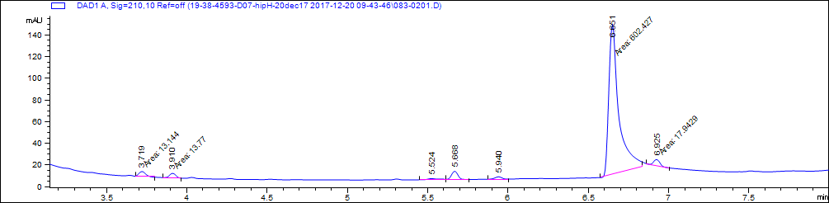

|  |  |  |  |
| --- | --- | --- | --- |
| # | Retention time (minutes) | Area | Area% |
| 1 | 3.7 | 13.1 | 1.9 |
| 2 | 3.9 | 13.8 | 2.0 |
| 3 | 5.5 | 8.0 | 1.2 |
| 4 | 5.7 | 24.9 | 3.6 |
| 5 | 5.9 | 12.4 | 1.8 |
| 6 | 6.7 | 602.4 | 87.0 |
| 7 | 6.9 | 17.9 | 2.6 |

**B**



M+1=398

**SI Figure 27.** LC-MS chromatograms for D07. Molecular weight estimated from mass spectrometry is 396.951 g/mol. (A) LC chromatogram and table of peak properties. %Area describes relative area under the curve of selected peaks and interpreted as an estimate of purity. (B) MS detection.

**A**

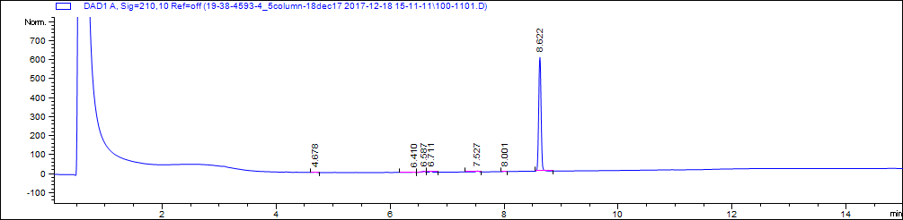

|  |  |  |  |
| --- | --- | --- | --- |
| # | Retention time (minutes) | Area | Area% |
| 1 | 4.7 | 5.4 | 0.3 |
| 2 | 6.4 | 5.6 | 0.3 |
| 3 | 6.6 | 22.7 | 1.2 |
| 4 | 6.7 | 18.1 | 1.0 |
| 5 | 7.5 | 16.1 | 0.9 |
| 6 | 8.0 | 5.6 | 0.3 |
| 7 | 8.6 | 1770.7 | 96.0 |

**B**



M+1=421

**SI Figure 28.** LC-MS chromatograms for D08. Molecular weight estimated from mass spectrometry is 420.461 g/mol. (A) LC chromatogram and table of peak properties. %Area describes relative area under the curve of selected peaks and interpreted as an estimate of purity. (B) MS detection.

**A**

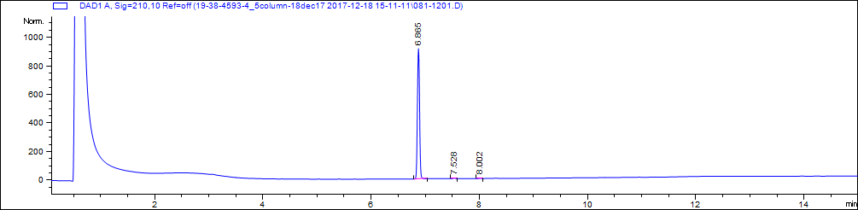

|  |  |  |  |
| --- | --- | --- | --- |
| # | Retention time (minutes) | Area | Area% |
| 1 | 6.9 | 2511.1 | 99.3 |
| 2 | 7.5 | 11.0 | 0.4 |
| 3 | 8.0 | 5.9 | 0.2 |

**B**



M+1=392

**SI Figure 29.** LC-MS chromatograms for D09. Molecular weight estimated from mass spectrometry is 391.42 g/mol. (A) LC chromatogram and table of peak properties. %Area describes relative area under the curve of selected peaks and interpreted as an estimate of purity. (B) MS detection.